**Computer Engineering Department**

**Faculty of Engineering Mahidol University**

# LAB01: Introduction to Image Processing Using MATLAB

## Objectives

Upon completion of this lab, you will be able to:

1. Use MATLAB to read and display images in a variety of image file types.
2. Describe the different types of images.
3. Understand the basics of MATLAB programming.
4. Write a user-defined function in MATLAB that converts the grayscale image to the binary image based on threshold.

**Introduction**

In MATLAB, an image is stored as a two-dimensional matrix, where the matrix contains the values of intensity of light of the pixels.

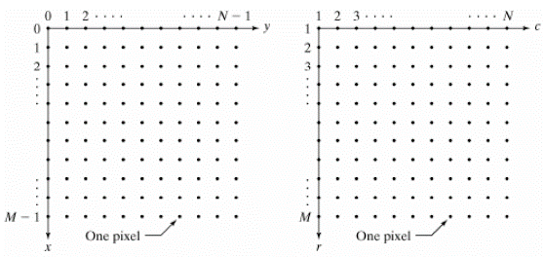

Figure 1: [Left] the usual image coordinates. [Right] the matrix coordinates of MATLAB.

Notice that the matrix coordinates in MATLAB originate at (r,c) = (1,1) instead of (x,y) = (0,0).

Four basic types of images are supported in MATLAB, including:

1. Binary image
2. Grayscale image
3. Indexed image
4. RGB image

The Image Processing Toolbox provides a set of basic tools for image processing that typically includes the following:

* **Converting Image Classes and Types**

im2bw - Convert image to binary image by thresholding

im2double - Convert image array to double precision

im2uint8 - Convert image array to 8-bit unsigned integers

im2uint16 - Convert image array to 16-bit unsigned integers

ind2gray - Convert indexed image to grayscale image

gray2ind - Convert grayscale image to indexed image

ind2rgb - Convert indexed image to RGB image

rgb2gray - Convert RGB image or colormap to grayscale

rgb2ind - Convert RGB image to indexed image

* **Displaying Images**

image - Create and display image object

imagesc - Scale data and display as image

imshow - Display image

colormap - Display color map

* **Importing and Exporting Images**

load - loads the variables from a MAT-file

imread - Read image file

imwrite - Write image file

imfinfo - Return information about image file

figure - Creates a figure on the screen

* MATLAB Program

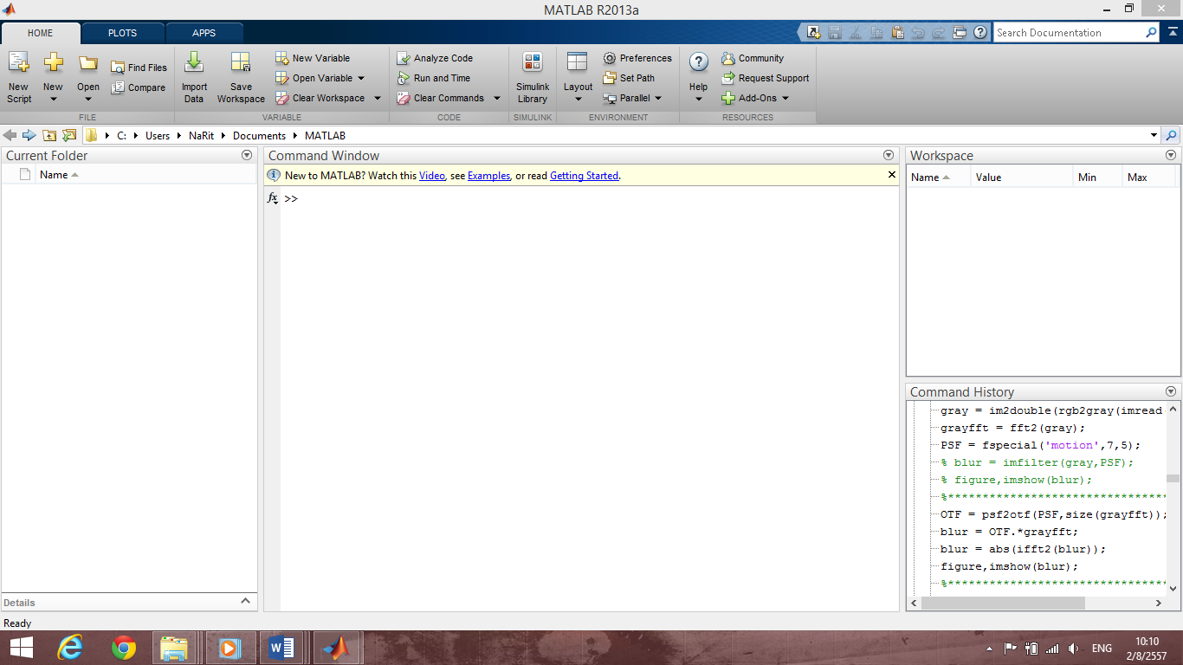Figure 2: The MATLAB with the default layout.

**Current working Folder**

**Command window**

**Workspace**

**Listed variable**

## Exercise

This exercise can be used as a reference for basic operations in the Image Processing Toolbox. To find out what commands are available in the Image Processing Toolbox, type "help images" or type “help command-name” will give you detailed information on what a function does and how to use it.

You can use the images provided in the folder **\Google Drive\EGCO486_60-1\LABs\LAB01** for your exercises. If you do not complete this exercise in one session, the variables you created will be erased when you exit MATLAB.

1. Use the **load** command, MATLAB built-in function, to import data into the MATLAB workspace from a file **ip01_1.mat**. Record the command you used in the box below.

|  |
| --- |
| load(‘ip01_1.MAT’); |

1. To list the currently active variables, use the **whos** command. Record your results in the box below.

|  |
| --- |
| Name Size Bytes Class Attributes  X 258x350 722400 double  caption 1x66 132 char  map 128x3 3072 double |

What is the meaning of each variable?

|  |
| --- |
| X คือ Matrix ที่มีค่าเป็น Double เป็นข้อมูลรูปภาพ ขนาด 258*350  Caption คือ String ที่มีค่าว่า “Trees with a View, Watercolor & ink on paper, (c) 1991 Susan Cohen”  Map คือ Matrix ที่มีค่าเป็น Double เป็นข้อมูลสีของภาพ ขนาด 128*3 |

1. Now consider the X variable in Exercise 2. Convert this X variable into binary image, grayscale image, and RGB image. Three images are stored in the X2, X3 and X4 variables, respectively. What command would you use to convert all images?

|  |
| --- |
| X2=im2bw(X,map)  X3=ind2gray(X,map)  X4=ind2rgb(X,map) |

What is the image type for X variable?

|  |
| --- |
| Indexed image |

1. Display the X, X2, X3, and X4 images using the **imshow** command and save all your results.

|  |
| --- |
|  |

1. Record the value of the pixel at coordinates (2,4) of the X, X2, X3, and X4 images.

|  |
| --- |
| X=106  X2=0  X3=0.7025  X4=0.5490 |

1. Use the **imread** command to read the following images “ip01_2.tif”, “ip01_3.tif”, and “ip01_4.tif”. Keep these images in the I1, I2, and I3 variables, respectively. Display and save all your results.

|  |
| --- |
|  |

1. Convert the I1 RGB image into indexed image with 256 colors, and indexed image with 16 colors. Keep these new images in the I4, and I5 variables, respectively. Display and save all your results.

|  |
| --- |
| [I4,map1]=rgb2ind(I1,256);    [I5,map2]=rgb2ind(I1,16); |

1. Make the diplay window of I2 image active and then use the **colormap**(jet) command. Observe output and record your result.

|  |
| --- |
|  |

1. Using the **colormap** command, convert the color map of the I2 image from jet to gray. After that save the resulting image.

|  |
| --- |
|  |

## When you have completed to convert the color map of the I2 image back to gray, you can use flipud command to flip the color map up to down. Record your result.

|  |
| --- |
|  |

## The im2bw command converts the grayscale image to the binary image based on thresholding. Thresholding means that a output image is generated in which each pixel has intensity 1 (white) if the corresponding pixel in the input image has a value above the threshold and 0 (black) otherwise.

In order to create your own function in MATLAB, write a program for converting the grayscale image to the binary image, with the following function name: **Myim2bw.m**. Using this program on the image “cameraman.tif” should give you result as shown in Figure 3.

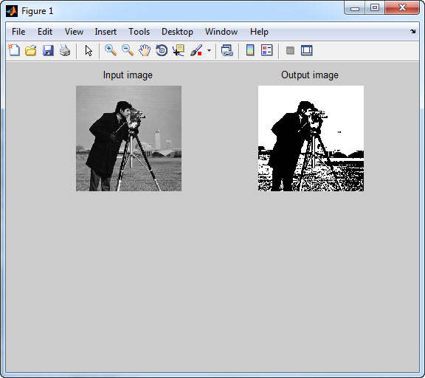

Figure 3: The result of converting the grayscale image into the binary image using the threshold of 0.5.

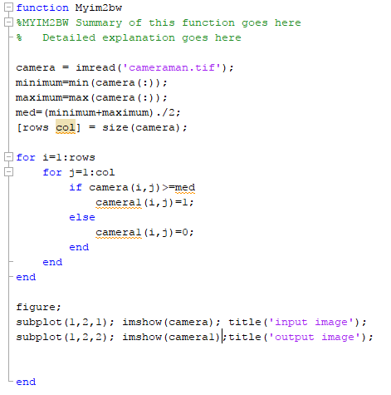

## (Extra credit) Write a MATLAB program that makes the reverse image readable, with the following name: Myim2rv.m. For example, the reverse image of the word "ambulance" is used to caution the driver of the vehicle ahead of ambulance. Using this program on the image “ambulance.bmp” should give you result as shown in Figure 4.

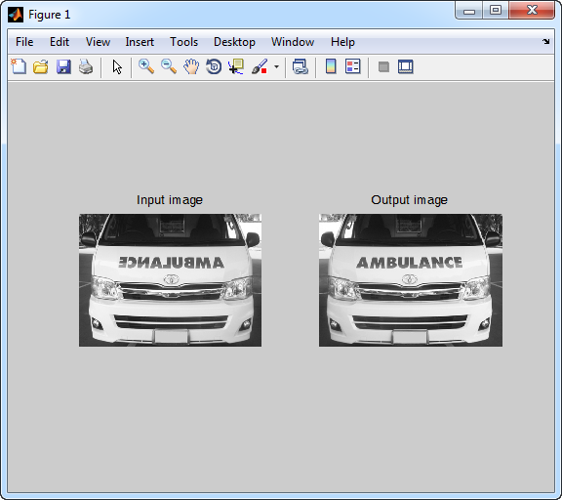

Figure 4: The result of making the reverse image readable.

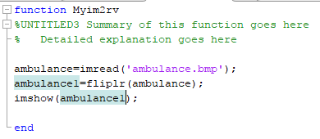

## Question

## Describe the characteristics of the image types, including the binary image, the grayscale image, the indexed image, and the RGB image.

## What is the range of pixel values of each image?

## How many colors are there in each image?

## What is the size of each image?

* 1. Binary image

|  |
| --- |
| Range of pixel = 0,1  Colors = 2 ขาวกับดำ  Size of image = m*n*2 |

* 1. Grayscale image

|  |
| --- |
| Range of pixel = 0-1 หรือ 0-255  Colors = 256  Size of image = m*n*256 |

* 1. Indexed image

|  |
| --- |
| Range of pixel = matrix m-n ที่มี map สีขนาด m-3  Colors = (256*256*256)-256 = 16,776,960 สี  Size of image = (m*n(ขนาดของ Index)+m*3(ขนาดของ Map))*256 |

* 1. RGB image

|  |
| --- |
| Range of pixel = matrix ขนาด m-n-3 มิติ ช่วงค่าตั้งแต่ 0-255  Colors = (256*256*256)-256 = 16,776,960 สี  Size of image = m*n*3*256 |

1. What are the advantages and limitations of indexed image?

|  |
| --- |
| สามารถเปลี่ยนโทนสี ได้ง่ายโดยเปลี่ยนค่าภายใน Matrix แต่เนื่องจากต้องเก็บค่าเป็น Matrix จึงทำให้ต้องใช้พื้นที่เยอะในการเก็บข้อมูล |

1. What is the differences between **image** and **imagesc** commands?

|  |
| --- |
| Imagesc คือการเรียกใช้คำสั่ง image ที่มีการ Scale Colormap ให้ครอบคลุม ซึ่งทำให้ปัญหาที่อาจเกิดขึ้น เช่น ค่าของ Matrix รูป มีค่ามากกว่า map(out of range) หรือการที่ ค่าของรูปเกาะกลุ่มกัน ทำให้สีที่ได้กลมกลืนกัน  คำสั่ง Imagesc จะมาช่วยแก้ปัญหา โดยการปรับค่าของรูปให้ครอบคลุมทั้ง Colormap |

**What you need to submit:**

Prepare a zip file that contains a document (docx extension) and the matlab files (m-file extension).

Double check that you have included all of the above in the zip file. Email the zip file to the account **send2narit@hotmail.com** with the following subject line: **EGCO486_LABxx_yyy**, which xx is a number of LAB and yyy is the last 3 digits of the student identification number. Your email should reach us within 4 days. There will be 20% penalty for late LAB submitted afterwards.

\*\***Please preserve a copy of your email and all your work until the end of the course.**